

**MASENO UNIVERSITY**

**SCHOOL OF COMPUTING AND INFORMATICS**

DEPARTMENT OF INFORMATION TECHNOLOGY

# **THE E-BURSARY SYSTEM**

**CIT 208: GROUP PROJECT**

P**ROJECT PROPOSAL SUBMITTED TO THE SCHOOL OF COMPUTING AND INFORMATICS IN PARTIAL FULFILMENT OF THE REQUIREMENTS FOR THE DEGREE OF BACHELOR OF SCIENCE IN INFORMATION TECHNOLOGY**

**MASENO UNIVERSITY**

**P.O. BOX PRIVATE BAG**

**MASENO, KENYA**

**OCTOBER, 2021**

# **DECLARATION**

This project proposal is our original work and has not been submitted to any other institution of higher learning for any award. Additionally, all materials herein which are not our work have been identified.

|  |  |  |
| --- | --- | --- |
| **ADM NO.** | **NAMES** | **SIGNATURE** |
| **CIT/00046/019** | **KATUMO BENSON MAKAU** |  |
| **CIT/00192/019** | **ODONGO BRIAN** |  |
| **CIT/00002/019** | **MUCHIRI VICTOR** |  |
| **CIT/00274/019** | **MUKETHA EVLYN** |  |
| **CIT/00144/019** | **STEPHEN GAKONYO** |  |

This project proposal has been submitted for examination with my approval as the university supervisor.

--------------------------------------------------- ------------------------------------

**James Chamwama Date**

**Instructor**

**Maseno University**

# **ABSTRACT**

There is a need to have a system with the necessary resources to help in filling, storing, and keeping track of the Students Organization of Maseno University (SOMU) bursary application scheme at Maseno University. With a population of over 15, 000 students, automating the whole process from application, vetting and allocation of bursaries to students would reduce paperwork for both students and the involved staff while still saving the time the students would spend queuing to submit forms. In the 21st century, making queues to submit forms ought to be something of the past. The E-Bursary aims to fill the gap by having a digital bursary management system for Maseno University’s SOMU funded scheme.

Maseno University is taken to be one of the best public universities in the country teaching Information Technology. They not only teach the students in the school of computing but also all those in other different faculties. In the university currently, bursary applications are conducted so manually that the students get to download the bursary forms from the university website, after which they are expected to fill them. After having all the forms filled, the students have to submit the forms physically to the person in charge of the same. Afterwards, the person in charge has to manually go through the applications one by one eliminating those who have attached wrong files or rather forged their applications or in one way do not qualify for the loan. Having done all that, the students have to wait for so long without the knowledge of whether their applications were verified or not since the only way to know is through the student’s portal where fee usually reflects.

The E-Bursary system is web-based. This is because the majority of the students own smartphones or even laptops which can however access websites when connected to a network. A student will be required to visit the website once the bursary application is open, register then sign in. Afterwards, the student will have to apply for the loan via the platform given to him/her then submit the application. Once submitted, students will be prompted into a dashboard where they can keep track of the whole process.

If this system is adopted in the whole university, students will have a comfortable and easy bursary application experience with a system that eases the whole process as well as serves fairness to every suitable applicant since manual handling of forms would be done away with completely. Additionally, there will be a reduction of paperwork since no one will be required to print or submit any hard copies.

# **ACKNOWLEDGEMENT**

We would like to express our sincere gratitude to our supervisor Mr. James Chamwama for providing his invaluable guidance, comments and suggestions throughout the course of this project.

Additionally, we would like to thank our friends Alexander Karanja and Stephen Mwau for their prompt inspirations, timely suggestions with kindness and enthusiasm.

# **TABLE OF CONTENTS**

Contents

**THE E-BURSARY SYSTEM** i

**DECLARATION** ii

**ABSTRACT** iii

**ACKNOWLEDGEMENT** iv

**TABLE OF CONTENTS** v

**LIST OF FIGURES** vii

**LIST OF TABLES** viii

**CHAPTER ONE: INTRODUCTION** 1

**1.1 Background Information** 1

**1.2 Problem Statement** 2

**1.3 General Objective** 2

**1.4 Specific Objectives** 2

**1.5 Justification** 2

**1.6 Project Scope** 3

**1.7 Assumptions** 3

**1.8 Limitations** 3

**CHAPTER TWO: LITERATURE REVIEW** 4

**2.1 Introduction** 4

**2.2 The Scope of Review** 4

**2.3 Criteria Used** 5

**2.4 Historical Background** 5

**2.5 Approaches** 6

**2.6 Previous Studies** 6

**2.7 General Conclusions** 7

**2.8 Conclusions** 7

**CHAPTER THREE: METHODOLOGY** 8

**3.1 Introduction** 8

**3.2 Research Design** 8

**3.3 Population of the Study** 8

**3.4 Sampling** 9

**3.5 Sample Size** 9

**3.6 System Requirements and Environment** 10

**3.7 Prototype Design** 10

**3.7.1 Requirement Gathering and Analysis** 10

**3.7.2 User Requirements Modelling** 11

**3.7.3 Database Design** 19

**3.7.4 Interface Design** 24

**CHAPTER FOUR: SYSTEM DEVELOPMENT AND IMPLIMENTATION** 26

**4.1 Development Environment: Hardware Components** 26

**4.2 Development Environment: Software Components** 26

**4.3 System Testing and Evaluation** 27

**4.3.1 Unit Testing** 27

**4.3.2 Integration Testing** 28

**4.3.3 System Testing** 28

**CHAPTER FIVE: RESULTS AND DISCUSSIONS** 29

**RESULTS AND DICUSSIONS** 29

**CHAPTER FIVE: CONCLUSION AND RECOMMENDATIONS** 32

**REFERENCES** 33

**APPENDICES** 34

**GANTT CHART** 34

# **LIST OF FIGURES**

Figure 1 Use Case Diagram 13

Figure 2 Student activity diagram 17

Figure 3 admin/Staff activity diagram 18

Figure 4 Entitty Relationship Diagram 23

Figure 5 login page design 24

Figure 6 Register Form 24

Figure 7 Student Dashboard 25

Figure 8 Admin Dashboard 25

Figure 9 Average no. of applications 30

Figure 10 Rate of form loss by staff 30

Figure 11 Rate of system reliability 31

# **LIST OF TABLES**

Table 1 Use case simplification table 14

Table 2 Use Case 1 14

Table 3 Use Case 2 14

Table 4 Use Case 3 15

Table 5 Use Case 4 15

Table 6 Use Case 5 15

Table 7 Use Case 6 15

Table 8 Use Case 7 16

Table 9 Student Details Table 19

Table 10 application Table 19

Table 11 Academic Details Table 19

Table 12 Grade Details Table 20

Table 13 Loan Details Table 20

Table 14 Bursary Details Table 20

Table 15 Complaint Table 20

Table 16 Student_complaint_Table 21

Table 17 Department Table 21

Table 18 Programme Table 21

Table 19 department_programme_table 21

Table 20 Sponsor Details Table 21

Table 21 Academic Year Table 21

Table 22 County Details Table 22

Table 23 Constituency Details Table 22

Table 24 county_constituency_table 22

Table 25 application_status_table 22

Table 26 Awarding Table 22

Table 27 Cheque Details Table 22

Table 28 Staff Response Raw data table 29

# **CHAPTER ONE: INTRODUCTION**

## **1.1 Background Information**

In any institution of higher learning, technology plays a major role in aiding smooth and efficient learning as well as operations of the institution, Maseno University being of no exception. One of the main goals is ensuring that the sharing and access of information is easy to all persons in the university. Therefore, being in the twenty-first century, it would be extremely important for higher institutions to adapt to the ever-changing technological trends to help them in sharing and access of information.

Maseno University is among the largest higher learning institutions in Kenya. With such a population, the ratio of students to subordinate staff stands at approximately 500:1. As it is evident, the student-staff interaction is a challenge and especially when it comes to rendering of services to the students. Students at times have complaints which may require immediate action by the staff. In the event that the staff are occupied at that moment, the issue may end up not solved, causing inconveniences. It is for that reason, a system is needed to fill in the gap identified above. The system will provide a platform where students would skip all the middlemen involved in the bursary application process and promote transparency in the complete bursary management cycle from application to disbursement to beneficiaries.

The challenge of having the students walk into offices to get a stamp from the authorized staff which at times is to no avail since they may be occupied at that particular time or not present, creates a delay to the whole bursary application process. The system would also provide a platform where all the rejected applicants would get notified as to why their applications were rejected. This would play a big role to the students since they may correct their mistakes if at all they are granted a second chance to apply.

Having such a platform would provide students with easy time and minimize the chances of causing a commotion in any office trying to submit their forms before the deadline and also bring about transparency of the whole bursary application process. To have such a platform implemented, it would bring about convenience and transparency in the whole process.

## **1.2 Problem Statement**

The existing bursary management system in Maseno University is expensive, time consuming and unreliable. The system is faced with challenges of transparency and fair allocation of bursaries to the needy students.

## **1.3 General Objective**

To develop an Online Bursary Management System for Maseno University.

## **1.4 Specific Objectives**

The following are the objectives of this proposed Maseno E-Bursary Project:

1. To identify the challenges associated with the existing system.
2. To identify the functional requirements of the proposed e-bursary system.
3. To design and implement the proposed e-bursary system.
4. To test the e-bursary prototype.

## **1.5 Justification**

At the university level, students need access to resources quickly and efficiently. This is very fundamental in the development of their skills and time management as they may need to be performing other different activities. Having this kind of resources available on their mobile phones, laptops, or desktop computers increases efficiency. In addition, students in the faculty of computing in any institution should be able to understand the technological trends and their effects and be able to solve an existing problem using the best algorithms that addresse the issue. Thus, having a web-based application that fetches resources, executes the fetched resources, and provides updated information to the end-user in no time is very essential.

This proposed project will aid in offering students a platform to apply, track their bursary application status, and a forum to present their complaints and get quick feedback from the staff. Elimination or minimization of long queues in offices will be possible because each student will be able to directly apply and track the whole process using their gadgets.

The proposed application will also assist the staff in vetting the applications and responding to complaints from students in a much easier and faster way. The staff will also be able to upload any news to the applicants via the dashboard provided to them. Through the web application, the students will be able to find all uploads from where they can view and download them. The application will be a handy tool for the students because it will promote transparency in the bursary application, minimize the cost of the applying, and provide a reliable system where each task would be automated thus saving on time. The staff will also benefit from the system as it will ease their work by reducing the paper work, and automating the vetting process which in the existing system takes days to partake.

## **1.6 Project Scope**

The prototype to be developed will include a user access interface that will allow users to register, login, input their personal information and apply for the bursary, a module that will display the application status to every applicant, a module to file complaints if any, and be able to view the responses in real time and a module to download information posted by the admin.

## **1.7 Assumptions**

1. Users have access to fast internet.
2. Users have devices which can surf through the web.
3. Users have the knowledge of the internet and how to browse.

## **1.8 Limitations**

The following are the limitations of this proposed Maseno E-Bursary project:

* Network downtime from the internet service providers may interfere with the whole bursary application process.
* Users must have devices with the capabilities to surf through the web.

# **CHAPTER TWO: LITERATURE REVIEW**

## **2.1 Introduction**

Traditionally, services have been conducted face to face in such a way that for one to get any service their physical appearance would be very important. However, the wide distribution of computers, mobile phones, and communication technologies has made the whole process much simpler. Since the arrival of mobile phones in the 1980s, they have been widely used by people of all ages all around the world (Arceneaux, 2005). It could be said that the whole world is becoming mobile; mobile phones and personal computers are not only communication devices but also portable and private pieces of technological equipment. Nowadays, mobile technologies are becoming increasingly networked. Such technologies can be used creatively in different areas. Using mobile technologies in organizations like learning institutions is a clear example of such an innovation. Laptops, Personal Computers, and even mobile phones equipped with internet connection have created the need for digitizing services such as job applications, learning processes and even conducting businesses. Internet-enabled communication devices can help students to access resources and services anytime, anywhere as long as they have an internet connection.

## **2.2 The Scope of Review**

At the university level, students need access to internet-available resources in a fast and convenient way. This is very fundamental in not only the development of their skills and class performance but also aims to bring the university services right into their devices. Having the services accessible via internet is a good practice. In addition, for the students in the faculty of Computing and Informatics in any institution, they should be able to understand the advancement of technological trends and their effects and come up with solutions for the existing problems employing the best algorithms that address the issues at hand. Thus, having a website application that fetches resources, processes them, and generates the output to both the students and involved staff in a more efficient way is good to them.

## **2.3 Criteria Used**

This literature review will be based on research about systems previously done, and which are related to this proposed system. The major focus will be on web-based applications that assist people apply for bursaries or any kind of funding online. Several web-based bursary application systems will be reviewed and investigated on how they have assisted people in the application processes. All the data collected about the various web-based applications will be analyzed and based on the analysis, the proposed system will be proved feasible or infeasible.

With the above at hand, existing literature will be subjected to investigation on web-based bursary application programs. The key concepts of the applications outlined, major relationships or patterns noted, key strengths and weaknesses identified and the research gaps will be outlined. The paper ends with a summary of agreements and disagreements in the literature, areas for further research, and the overall perspective.

## **2.4 Historical Background**

Many web-based applications have been developed for mobile platforms. Over the last few years, these applications have been the focus not only of technical interests, but also marketing and business campaigns.

Recently, many researchers have focused on mobile and web technologies. This literature review will be based on a research about the systems previously done, and which are related to this proposed system. The major focus on the same will be on bursary management applications which are already in existence whereby each of their strengths and weaknesses will be determined. The E-bursary system is a web-based application that can be accessed using mobile phones, laptops, desktop computers or generally any internet enabled device with the capabilities to surf through the web. The difference between the E-bursary system and the current bursary application system is that E-Bursary system can be accessed anywhere at any time as long as you have internet connection while the current one entails physically submitting the forms to the respective offices.

## **2.5 Approaches**

Approaches towards this review will be based on the web-based application systems that assist people in making their various applications processes online such as loan applications. Therefore the functionality of these websites will be determined and their strengths and weaknesses evaluated.

To achieve this, both a questionnaire and an interview research methodologies will be used to clarify the research inquiry and if the inquiry is imperative or not.

## **2.6 Previous Studies**

After doing a broad research, the following web-based bursary/loan application systems were found to assist people making online applications. Such applications include:

**Mwala NG-CDF Online Bursary Application System**

It’s a bursary management system developed for Mwala Constituency students in Machakos County in Kenya who are in higher learning institutions to help them apply for the NG-CDF funded bursary scheme online. Any student from the same constituency can apply for the bursary from anywhere in the world. The system is designed in such a manner that only students from the defined constituency can apply (Mwala NG-CDF Online Bursary , 2020). When the application process is open, the system generates bulk messages to all the registered students informing them that the application is open. On disbursement, the system also generates bulk messages to the parents informing them that their child was awarded a certain amount of money from Mwala CDF.

However, despite being such a helpful system, with it comes some drawbacks namely:

* The system doesn’t give the students a platform to file their complaints if at all they have any.
* In the event an application is dismissed, the applicant doesn’t get any message communicating to them why their application was dismissed.

**Higher Education Loans Board (HELB)**

HELB is a statutory body which was established in 1995 by an Act of Parliament ‘Higher Education Loans Board Act’ in Kenya. The body has a system through which the government supports students in higher learning institutions by financing their education. The system allows for students from colleges and universities to apply for loans. The system also keeps track of the student’s educational progress and after completing their studies, the students are then expected to repay the loan awarded to them by the government (Higher Education Loans Board, 1995). The board also has a system which allows students who need more funding to appeal for the same.

The drawbacks of this system however includes:

* This system does not provide a platform through which students can file complaints and for that reason they end up sending their complaints to HELB via their social media handles.
* For a student to apply for a loan from the Helb board, he or she must own a Kenyan Identification Card. This creates an unfair situation and especially to the students who have had the chance to join higher learning institutions before attaining the age of 18 years.

## **2.7 General Conclusions**

After analysis of the review was done, the findings were that there is not yet any website that can solve the problem existing in the Students Organization of Maseno University (SOMU) bursary scheme fully. Therefore, there will be the need for a system that will assist students of Maseno University to have a convenient and transparent bursary application process.

## **2.8 Conclusions**

In conclusion, the above literature review shows that there are efforts to assist students to have a convenient and transparent loan/bursary application systems. Some have even gone an extra mile of providing a platform where the students can appeal if they need their loan incremented.

Having such a platform that would have all the modules defined in the named systems with an addition of a module to file their complaints with real time response from the administration would bring about convenience and transparency in the loan/bursary application process.

As a result this literature review permits and qualifies the implementation of a bursary management system which will not only fill the existing gap but also improve the user experience with a more user-friendly, convenient and transparent bursary management system.

# **CHAPTER THREE: METHODOLOGY**

## **3.1 Introduction**

Research refers to a specific and systematic search for pertinent information or evidence on a certain subject of interest. Research methodology incorporates principles practices and procedures required to carry out research. This chapter describes the steps, procedures, techniques and tools used to realize the research objectives and is organized as follows: Study Population, Sampling Technique and Sample size, User Requirements Analysis, Prototype Functional and Nonfunctional Requirements Gathering and Analysis procedure, Prototype Design, Development and Testing of the prototype and evaluation of functionalities of prototype and ethical considerations.

## **3.2 Research Design**

The proposed research design for the study is exploratory research design. Since the research explores and attempts to test a prototype and establish its performance, the steps that will be undertaken will be as follows:

1. Defining the project scope
2. User requirements gathering and analysis
3. Prototype functional requirements identification and specification.
4. Prototyping the web-based Maseno E-Bursary system.
5. Testing of the prototype.

## **3.3 Population of the Study**

The population of this study will entail the SOMU bursary management staff that includes the SOMU officials, the administration staff and then Maseno University students who have had applied for the SOMU bursary before and those who have not yet applied for the bursary. The total population is expected to consist of hundred people: five SOMU officials, five administration staff, forty five students who have had applied for the SOMU bursary before and forty five students who have not yet applied for the bursary. This population will help us gather the information required during a bursary application process in order to efficiently vet the applicants, award them and process the funding to the applicant’s school accounts conveniently and with transparency.

## **3.4 Sampling**

The study proposes the use purposive Sampling technique. Purposeful sampling is widely used in qualitative research for the identification and selection of information-rich cases related to the phenomenon of interest (Tongco, 2007). This study will identify individuals that interact directly with the current bursary management system to identify the requirement, the procedures, the challenges and the workflow of the bursary management from application, vetting, awarding and disbursement of funds.

## **3.5 Sample Size**

Mugenda and Mugenda (Mugenda, 2003) explain that a population is a group of individuals or objects that have the same form of characteristics. They are the “totality of cases that conform to certain specifications, which defines the elements that are included or excluded in the target group”. This study focuses on the bursary management system in Maseno University, Kenya and the entities that interact with it. The sampling size is to be aimed at 100 individuals distributed in ratio among the individuals that interact with the current SOMU bursary management system in Maseno University. As mentioned above in the population of study, the population of this study involves the SOMU bursary management staff that includes the SOMU officials, the administration staff and then Maseno University students who have had applied for the SOMU bursary before and those who have not yet applied for the bursary. Therefore there 5 SOMU officials, five administration staff and forty five students who have had applied for the SOMU bursary before and forty five other students who have never applied for the SOMU bursary. This will ensure the quality of information rather than the quantity of information. Depending on the levels of interaction with the system, the number will be divided so that there is equal coverage and adequate collection of the information we require in our study.

## **3.6 System Requirements and Environment**

System requirements are all the necessary requirements that devices and computers must have for the proper functioning of a system efficiently without any problems incurred.

**Minimum System requirements for users**

1. Mobile phone or tablet running Android or iOS.
2. Internet connectivity, Wi-Fi, 2G, 3G or 4G connectivity.
3. Browser application such as Google Chrome, Mozilla Firefox, Safari browser or Opera Mini that can execute and has JavaScript enabled.

**Minimum System requirements for Administration staff and The Students Organization of Maseno University (SOMU) Leaders**

1. A desktop computer or laptop.
2. Internet connectivity, Wi-Fi or Ethernet connection
3. Browser application such as Google Chrome, Mozilla Firefox, Safari browser or Opera Mini that can execute and has JavaScript enabled.

## **3.7 Prototype Design**

The study proposes to several tools to model the prototype. UML is a collection of diagrams and models that are used in representing the analysis, design and implementation of systems in an object-oriented approach. The UML models provide an effective way to represent the design of proposed system prototype include; use case diagrams and Entity Relational Diagrams which will be well explained.

### **3.7.1 Requirement Gathering and Analysis**

Requirements will be gathered before and after the prototype has been developed. Gathering of the requirements before prototype development will enable the developer to understand the user specifications that need to be in the system, for it to have an impact on the target audience. After the development of the prototype, the data collected will enable the developer to gauge the user experience of the system and make changes where possible. The requirements gathering and analysis will be accomplished using primary and secondary data.

**Primary Data Sources**

**Structured Online Questionnaires**

This will enable the researcher to get answers to specific questions which will help in prototype design. The researcher will use this method both before and after prototype development. This will help in understanding user requirements (before development) and gauging user experience (after development). This method will be used because it is quick and easy to use, besides getting specific results needed. Furthermore, the questionnaires will be online because internet access is widely available and guarantees quick response.

**Open Interviews**

This will enable us get more information concerning the system. Since the interviews are not closed, the respondent is at liberty to give more detail concerning the system, which helps have a deeper understanding of user requirements and user experience.

**Secondary data sources**

Collection of this means that we will collect information on existing systems. The internet will be a powerful tool here, since we will use it to explore tools, frameworks and architectures closely related to our proposed prototype, as well as the challenges on existing systems that we will prove the fact that the use of technology in the proposed prototype will overcome the challenges.

Data analysis involves breaking the data into smaller pieces, which can be easily understood and aid in decision making. In our case we will use tables to analyze quantitative data.

### **3.7.2 User Requirements Modelling**

##### **3.7.2.1 Use Case Modelling**

The use case (figure 1.1) has three actors: primary actor (student), the administration staff actor and the system actor.

The primary actor is one who primarily benefits from the execution of the use case, that is, the user who applies for bursary. The administration staff actor is the one who directly interfaces with the system to initiate processing the application made by the user. The system actor provides the platform to execute events and relay the output to the user and the staff.

This will require the use of use case diagrams to show the tasks performed by the system, together with the people who will perform them. The figure below represents the interactions.

Figure Use Case Diagram

System

Student

Staff

Student

System

**BURSARY MANAGEMENT SYSTEM**

Staff

Figure 1.

To ease the understanding of the use case diagram drawn above, we will use a table.

|  |  |
| --- | --- |
| **Actor** | **Use Case** |
| Student | Register in the system |
| Student | Request login |
| System | Authenticate login request |
| Student | Apply for bursary |
| Staff | Authenticate the application |
| System | Generate application reports |
| Student and Staff | View generated reports |

Table 1 Use case simplification table

The student use case will deal with registering and making a login request, a task initiated by the student. This will require the user to click on a button to send the login request on the webpage. The student will login with some predefined details such as their names, registration number and email address. The system use case then authenticates the login request and if the request is valid, the student is logged in, a task initiated by the system automatically. The student the make a bursary application, a task initiated by the student. After submission, the application is authenticated by the staff, a task initiated by the staff. The system use case then generates application reports based on the event performed by the staff and the student use case. Both the staff and student use case are then able to view the generated reports.

The first use case is described more in detail in table 2 below. The second, third, fourth, fifth, sixth and the seventh use cases are described in detail in tables 3, 4, and 5,6,7,8 respectively.

|  |  |
| --- | --- |
| **ID** | **CASE 1** |
| TITLE | Register in the system |
| DESCRIPTION | Fill a form and click a button to submit registration details |
| ACTORS | Student |
| PRE-CONDITIONS | none |
| POST-CONDITIONS | None |
| SUCCESS SCENARIO | The user successfully submits the registration details |

Table 2 Use Case 1

|  |  |
| --- | --- |
| **ID** | **CASE 2** |
| TITLE | Authenticate Login Request |
| DESCRIPTION | Click a button on the web page that automatically makes a login request. |
| ACTORS | Student |
| PRE-CONDITIONS | The user is registered on the system |
| POST-CONDITIONS | None |
| SUCCESS SCENARIO | The user successfully makes the login request |

Table 3 Use Case 2

|  |  |
| --- | --- |
| **ID** | **CASE 3** |
| TITLE | Authenticate login request |
| DESCRIPTION | Match login request with recorded details in the database and vet the login request |
| ACTORS | System |
| PRE-CONDITIONS | The user made a login request |
| POST-CONDITIONS | None |
| SUCCESS SCENARIO | The user successfully logs in the system |

Table 4 Use Case 3

|  |  |
| --- | --- |
| **ID** | **CASE 4** |
| TITLE | Apply for bursary |
| DESCRIPTION | Fill the form provided dully and click on a button to submit the form. |
| ACTORS | Student |
| PRE-CONDITIONS | The user is logged in |
| POST-CONDITIONS | None |
| SUCCESS SCENARIO | The user successfully submits the form |

Table 5 Use Case 4

|  |  |
| --- | --- |
| **ID** | **CASE 5** |
| TITLE | Authenticate the application |
| DESCRIPTION | Check is the submitted data is valid |
| ACTORS | Staff |
| PRE-CONDITIONS | The user made an application |
| POST-CONDITIONS | None |
| SUCCESS SCENARIO | The staff authenticates the application made by the student |

Table 6 Use Case 5

|  |  |
| --- | --- |
| **ID** | **CASE 6** |
| TITLE | Generate application reports |
| DESCRIPTION | Automatically generate reports of the application. |
| ACTORS | System |
| PRE-CONDITIONS | The student made the application and the staff authenticated it appropriately. |
| POST-CONDITIONS | None |
| SUCCESS SCENARIO | The system displays the reports to the student and staff on their user interfaces |

Table 7 Use Case 6

|  |  |
| --- | --- |
| **ID** | **CASE 7** |
| TITLE | View Generated reports |
| DESCRIPTION | Automatically view the details of the generated reports |
| ACTORS | Student, Staff |
| PRE-CONDITIONS | The system generated the reports |
| POST-CONDITIONS | None |
| SUCCESS SCENARIO | The student and the staff can view the reports |

Table 8 Use Case 7

##### **3.7.2.2 Activity Diagrams**

Student activity diagram

Figure Student activity diagram

Launch Web app

Login

Success?

No

Yes

Make an application

Success?

View bursary status

yes

no

Complaints?

yes

File Complaint

View Complaint

response

No

Logout

Figure admin/Staff activity diagram

Launch Web app

Login

Success?

View applications

Validate applications

Is valid?

Approve

Allocate amount and cheque number

Disburse funds

Disapprove

Any Complaints

Respond to complaints

Logout

No

yes

No

Yes

### **3.7.3 Database Design**

This design is responsible for defining the structure in which data is stored, processed and accessed in the whole system. It will determine the speed of access, efficiency and amount of storage space required by the specific files and entries.

**Student Details Tables**

|  |  |  |
| --- | --- | --- |
| **Attribute** | **Data Type** | **Description** |
| **regNum(pk)** | Varchar(100) | Stores student’s registration number (Primary Key) |
| **FirstName** | Varchar(255) | Stores student’s first name |
| **MiddleName** | Varchar(255) | Stores student’s middle name |
| **LastName** | Varchar(255) | Stores student’s last name |
| **emailAddress** | Varchar(255) | Stores student’s email address |
| **phoneNumber** | Varchar(255) | Stores student’s phone number |
| **Password** | Varchar(255) | Stores student’s encrypted password |
| **date_created** | datetime | Stores the date the student record was entered |

Table 9 Student Details Table

|  |  |  |
| --- | --- | --- |
| **Attribute** | **Data Type** | **Description** |
| **applicationID** | Int(11) | Stores each student’s application id (Primary Key) |
| **regNum(pk)** | Varchar(100) | Stores student’s registration number |
| **YearofStudy** | Varchar(255) | Stores student’s Year of study |
| **departmentID** | Int(11) | Stores department ID from which the student belongs |
| **countyID** | Int(11) | Stores student’s county ID |
| **sponsor** | Varchar(255) | Stores student’s sponsor details |
| **statusID** | Int(11) | Stores the application status id |
| **awardingID** | Int(11) | Stores the application’s awarding id |
| **date_created** | datetime | Stores the date the student record was entered |

Table application Table

|  |  |  |
| --- | --- | --- |
| **Attribute** | **Data Type** | **Description** |
| **regNum(pk)** | Varchar(100) | Stores student’s registration number (Primary Key) |
| **gradeID** | Int(11) | Stores student’s grade ID |
| **attachmentName** | Varchar(255) | Stores the name of the attached student’s transcript |

Table Academic Details Table

|  |  |  |
| --- | --- | --- |
| **Attribute** | **Data Type** | **Description** |
| **gradeID(pk)** | Int(11) | Stores grade id (Primary Key) |
| **Description** | Int(11) | Stores the grade Letter |
| **Comment** | Varchar(255) | Stores the description of each grade |

Table Grade Details Table

|  |  |  |
| --- | --- | --- |
| **Attribute** | **Data Type** | **Description** |
| **loanID(pk)** | Int(11) | Stores the loan ID of each applicant(Primary Key) |
| **loanAmount** | Float | Stores the loan amount awarded |
| **awardingOrganization** | Varchar(255) | Stores the Name of the awarding organization |
| **attachmentName** | Varchar(255) | Stores the name of the attached file |
| **awardPeriod** | year | Stores the period the loan was awarded in years |
| **applicationID** | Int(11) | Stores the application id of the applicant |

Table Loan Details Table

|  |  |  |
| --- | --- | --- |
| **Attribute** | **Data Type** | **Description** |
| **bursaryID(pk)** | Int(11) | Stores the bursary ID of each applicant  (Primary Key) |
| **bursaryAmount** | Float | Stores the bursary amount awarded |
| **awardingOrganization** | Varchar(255) | Stores the Name of the awarding organization |
| **attachmentName** | Varchar(255) | Stores the name of the attached file |
| **awardPeriod** | year | Stores the period the loan was awarded in years |
| **applicationID** | Int(11) | Stores the application id of the applicant |

Table Bursary Details Table

|  |  |  |
| --- | --- | --- |
| **Attribute** | **Data Type** | **Description** |
| **complaintID(pk)** | Int(11) | Stores complaint ID of each applicant  (Primary Key) |
| **complaintName** | Varchar(255) | Stores the complaint Name |

Table Complaint Table

|  |  |  |
| --- | --- | --- |
| **Attribute** | **Data Type** | **Description** |
| **id(pk)** | Int(11) | Stores complaint ID of each applicant  (Primary Key) |
| **applicationID** | Varchar(255) | Stores the application id of the complainant |
| **complaintID** | Int(11) | Stores the complaint ID (Foreign Key) |
| **complaintDescription** | Varchar(255) | Stores the Description of the complaint |

Table Student_complaint_Table

|  |  |  |
| --- | --- | --- |
| **Attribute** | **Data Type** | **Description** |
| **dptid(pk)** | Int(11) | Stores department id(Primary Key) |
| **departmentName** | Varchar(255) | Stores the department Name |

Table Department Table

|  |  |  |
| --- | --- | --- |
| **Attribute** | **Data Type** | **Description** |
| **id(pk)** | Int(11) | Stores programme id(Primary Key) |
| **programmeName** | Varchar(255) | Stores the programme Name |

Table Programme Table

|  |  |  |
| --- | --- | --- |
| **Attribute** | **Data Type** | **Description** |
| **id(pk)** | Int(11) | Primary Key (Auto Increment) |
| **dptid** | Int(11) | Stores the department id |
| **programmeid** | Int(11) | Stores the Programme id |

Table department_programme_table

|  |  |  |
| --- | --- | --- |
| **Attribute** | **Data Type** | **Description** |
| **sponsorid(pk)** | Int(11) | Stores the Sponsor ID |
| **sponsorName** | Int(11) | Stores name of the sponsor |

Table Sponsor Details Table

|  |  |  |
| --- | --- | --- |
| **Attribute** | **Data Type** | **Description** |
| **id(pk)** | Int(11) | Stores academic year id (Primary Key) |
| **year** | Varchar(255) | Stores description of each academic year |

Table Academic Year Table

|  |  |  |
| --- | --- | --- |
| **Attribute** | **Data Type** | **Description** |
| **countID(pk)** | Int(11) | Stores county id (Primary Key) |
| **countyName** | Varchar(255) | Stores County Name |

Table County Details Table

|  |  |  |
| --- | --- | --- |
| **Attribute** | **Data Type** | **Description** |
| **constituencyID(pk)** | Int(11) | Stores constituency id (Primary Key) |
| **constituencyName** | Varchar(255) | Stores the constituency Name |

Table Constituency Details Table

|  |  |  |
| --- | --- | --- |
| **Attribute** | **Data Type** | **Description** |
| **Id (Primary Key)** | Int(11) | Primary Key (Auto Increment) |
| **countid** | Int(11) | Stores county id (Foreign Key) |
| **constituencyid** | Int(11) | Stores constituency id (Foreign Key) |

Table county_constituency_table

|  |  |  |
| --- | --- | --- |
| **Attribute** | **Data Type** | **Description** |
| **Id (Primary Key)** | Int(11) | Stores the status id (Primary Key ) |
| **statusName** | Varchar(255) | Stores the name of the status |

Table application_status_table

|  |  |  |
| --- | --- | --- |
| **Attribute** | **Data Type** | **Description** |
| **awardingID (Primary Key)** | Int(11) | Stores the awarding id (Primary Key ) |
| **amountAwarded** | Float | Stores the amount awarded to each applicant |
| **chequeID** | int | Stores the cheque id for each awarding |

Table Awarding Table

|  |  |  |
| --- | --- | --- |
| **Attribute** | **Data Type** | **Description** |
| **chequeId (Primary Key)** | Int(11) | Stores the cheque id (Primary Key ) |
| **chequeNumber** | int | Stores the cheque number |
| **chequeAmount** | Float | Stores the cheque amount |

Table Cheque Details Table

**Entity Relationship Diagram**

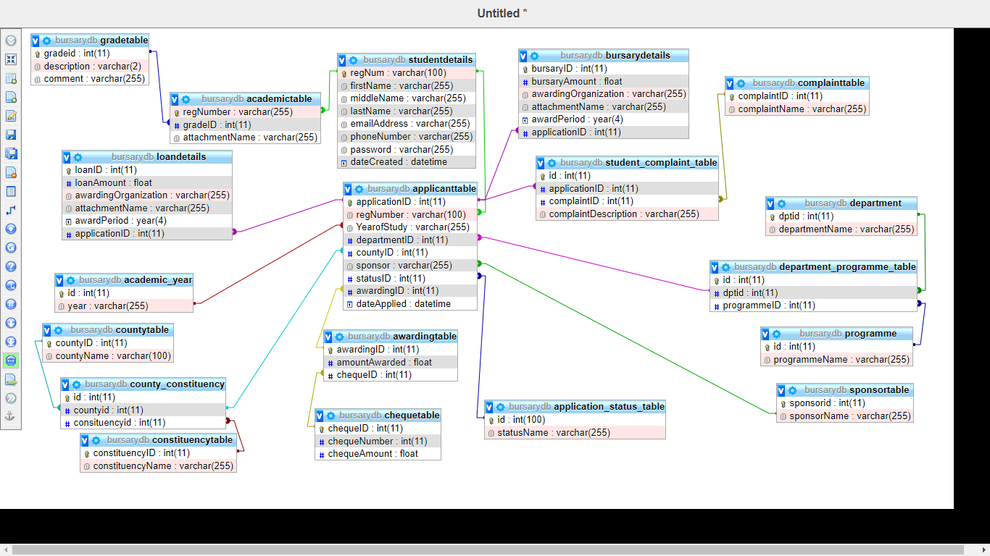

Figure 4 Entity Relationship Diagram

### **3.7.4 Interface Design**

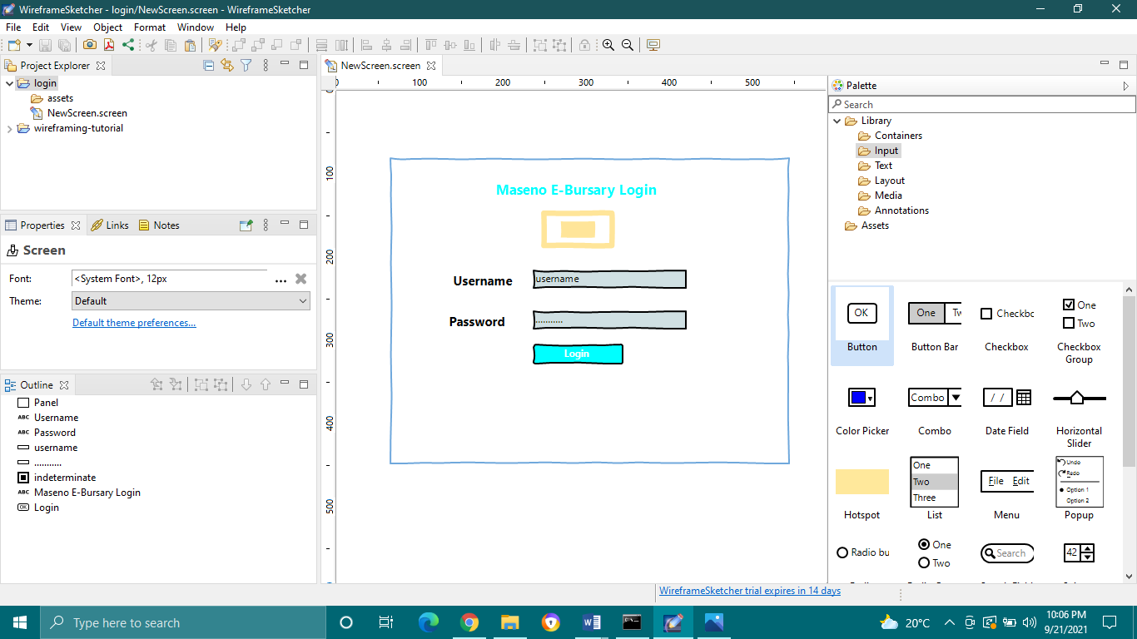

Figure 5 login page design

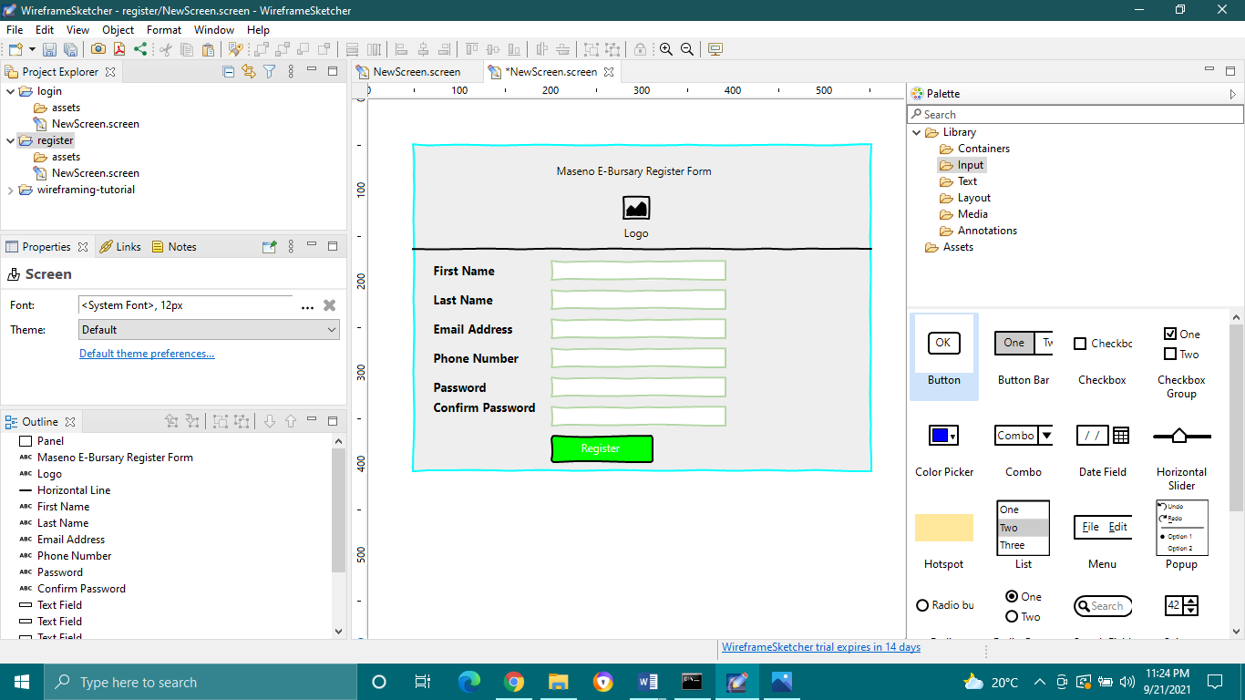

Figure 6 Register Form

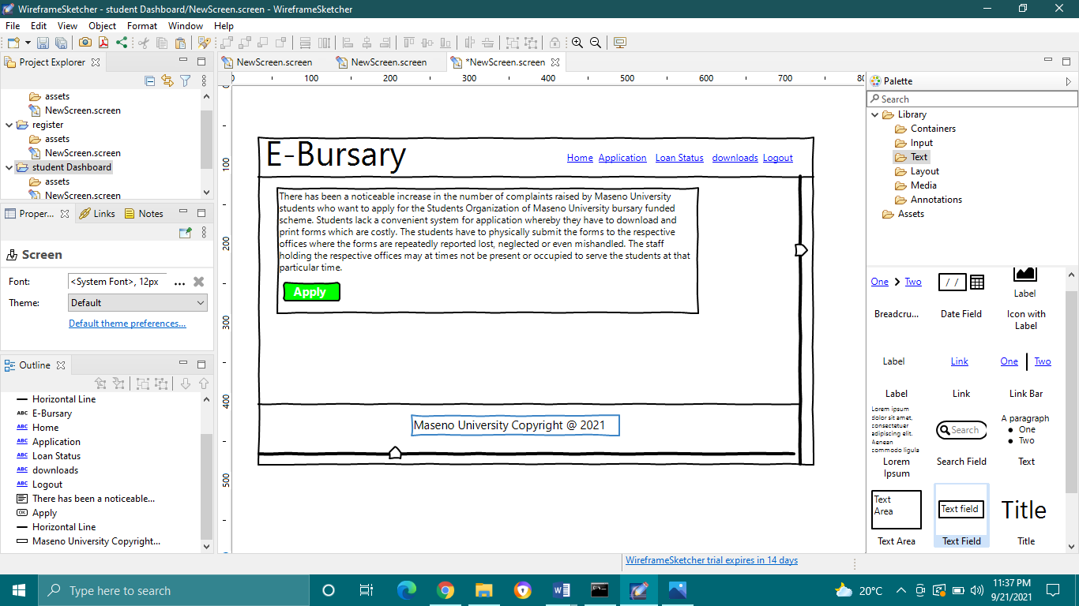

Figure 7 Student Dashboard

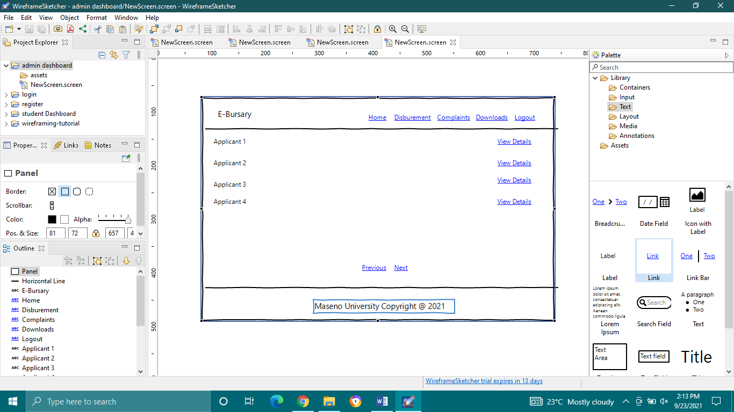

Figure 8 Admin Dashboard

# **CHAPTER FOUR: SYSTEM DEVELOPMENT AND IMPLIMENTATION**

## **4.1 Development Environment: Hardware Components**

These is a list of hardware components that will be used in making the Maseno E-Bursary System.

System devices include:

**Brand:** HP Notebook

**Processor:** Intel ® Core™ i5-5200U CPU @ 2.20 GHz, 2201 MHz, 2Core(s)

**Hard Disk:** 1TB hard drive

**RAM:** 8GB RAM

## **4.2 Development Environment: Software Components**

The following are the software components used in making of the Maseno E-Bursary:

**Windows Operating System**

Used as the interface between the user and the hardware. Allows installation of applications.

**Version:** Windows 10 Pro

©Microsoft Corporation

**Visual Studio Code**

Visual Studio Code is a code editor made by Microsoft for Windows, Linux and macOS. Features include support for debugging, syntax highlighting, intelligent code completion, snippets, code refactoring, and embedded Git.

**MAMP**

MAMP is a free and open-source cross-platform web server solution stack package developed by Apache Friends, consisting mainly of the Apache HTTP Server, MariaDB database, and interpreters for scripts written in the PHP and Perl programming languages.

It’s an application meant to provide a web and database server environment to the user on a local machine.

**ClickUp**

ClickUp is a cloud based collaboration and project management tool. It was used in task allocation, and time allocation for every activity.

## **4.3** **System Testing and Evaluation**

This is the process of evaluating the system and making sure all the errors made during developments are dealt with. Errors that may occur as a result of user input are also tackled in this phase. The system will have different levels of doing the same.

**Unit testing**- individual units will be tested for bugs.

**Integration testing**- units that interact with each other will be tested of any bugs

**System testing**- the whole system will be tested for any errors while fully

Implemented.

**User/acceptance testing**- the system will be given to several end users and they will rate usability and user friendliness.

### **4.3.1 Unit Testing**

There are several individual modules to undertake testing. These are:

1. **Student-based modules**

Registering into the system, logging in to the system, making an application, viewing application status, filing complaints, and viewing downloads.

1. **Admin-Based modules**

Logging into the system, viewing the lit of applicants, vetting the applications, updating application status, payments status, allocation status and disbursement status, Viewing filed complaints and responding to them, and Uploading downloads

These units will be tested individually. A perfect unit is a unit with no errors.

### **4.3.2 Integration Testing**

Several modules require other modules to work. Viewing of applicants by the admin requires the bursary application module to work, the viewing of loan status requires the admin’s updating loan status module, the viewing downloads by the students requires the admin’s upload of downloads. A perfect system will allow for smooth integration of the systems dependent on each other.

### **4.3.3 System Testing**

At the end of development, all the modules having being tested individually and integration checked, will be combined and tested as a whole. The modules when combined should work as a single unit. A perfect system should run and integrate all the modules without any errors.

**4.3.4 User Testing**

Several students from the school of computing Maseno University will interact with the system and give feedback on usability and user friendliness. SOMU leaders and Staff from the office of the Registrar will test the website for complete functionality of the admin dashboard, its user friendliness, and convenience of the system. A perfect system will receive good comments from all kinds of users and the users should be able to navigate all the modules with ease.

# **CHAPTER FIVE:** **RESULTS AND DISCUSSIONS**

## **RESULTS AND DICUSSIONS**

As stipulated in the chapter three above, questionnaires were distributed across a range of actors in Maseno E-Bursary system. These questionnaires were later on collected after being filled and the raw data analyzed and tabulated in form of pie charts.

The respondents of the questionnaires included some set students, SOMU leaders and some of the staff from the Registrar’s office from their large domain.

Staff’s and SOMU leaders’ questionnaire was set up to find out about the whole process from how they vet applicants to disbursement stage.

This is a survey aimed at finding out the need for an application to help manage bursary applications in Maseno University. Sample raw data of the responds is as follows:

|  |  |  |  |  |
| --- | --- | --- | --- | --- |
| **Respondent**  **(Staff)** | **Average no. of applications**  **Handled (per semester)** | **Rate of form loss or misplacement**  **(1-10)** | **Rate of system reliability**  **(1-10)** | **Challenges** |
| Responded 1 | >250 | 8 | 2 | Too much paper work |
| Responded 2 | >300 | 7 | 3 | Processes are very manual |
| Responded 3 | >200 | 8 | 1 | Poor handwriting by students. |
| Responded 4 | >300 | 9 | 2 | Form misplacement,  Tearing of forms |
| **Average Case** | **>200** | **8** | **2** | **System not reliable and convenient.** |

Table 28 Staff Response Raw data table

From the tabulated results, it is clear to say that, the staff personnel handle more than 200 bursary applications in a semester.

The results when presented in a graph would be as follows:

Figure 9 Average no. of applications

Figure 10 Rate of form loss by staff

Figure 11 Rate of system reliability

# **CHAPTER FIVE:** **CONCLUSION AND RECOMMENDATIONS**

This system will make it easy for students to access resources right through their smart

Phones. It will help save time since the application shall contain all the services via the web and every student could access them via their smartphones. Additionally, the students will also view downloads uploaded by the admin staff and file complaints concerning the bursary via the web using their mobile phones rather than going to the respective offices. The staff will upload downloads from their web application interface which will then appear on the student dashboard. Additionally, the staff will able to view and respond to the complaints raised by students still using the web application. The web app will majorly assist the students in applying for bursaries in Maseno University, track the status of their application, file complaints if any via the same platform and view all the downloads uploaded for them.

The application will still help the staff administer their services faster, in a convenient manner and reduce paper work for them. This will enhance convenience, reliability and transparency for not only the students but also the staff handling the applications. All the services stated above will be available via the web and therefore, one need not to switch to a pc to access them since they can be access via the mobile at any time. The system will be very user friendly, simple for the users both students and staff to navigate through. Usability and functionality of the system will also be enhanced. The future works on this project would include developing the forum module to assist in having real time interactions between the staff and the students, sort applicants based on the staff’s needs for easy vetting, and generate reports of all the actions taken. For example List of applicants not verified and why, list of beneficiaries, the date all the actions were processed etc. The project can even grow farther to serve other universities in the country.

# **REFERENCES**

Arceneaux, N. (2005). The world is a phone booth:. *The American response to mobile phones, 1981-2000*.

*Higher Education Loans Board*. (1995). Retrieved from https://www.helb.co.ke/.

Mugenda, O. M. (2003). Research Methods: Sample size determination. *African Centre For Technology Studies.*

*Mwala NG-CDF Online Bursary* . (2020, December). Retrieved from https://www.mwalacdf.co.ke/.

Tongco, M. D. (2007). Purposive sampling as a tool for informant selection. *Ethnobotany Research and applications*, pp. 147-158.

# **APPENDICES**

# **GANTT CHART**

This is graphical representation with vertical columns listing the activities and horizontal

Column showing the time calendar and bars whose length corresponds to the duration of each activity.

|  |  |  |  |  |  |  |
| --- | --- | --- | --- | --- | --- | --- |
| **Sub task** | **August** | | **September** | | **October** | |
| Project ideas |  |  |  | |  | |
| **Chapter 1**  Introduction  **Chapter 2:**  Literature Review  **Chapter 3:**  Methodology |  |  |  |  |  | |
| **Chapter 4**  -Data collection and analysis  -System design and Implementation  **Chapter 5**  Results and Discussions |  | |  |  |  |  |
| Final copy of the working prototype and presentation |  | |  | |  |  |